**PROBLEM – 6** For each event plan, list the plan number, count of the event plan lines, and sum of the number of resources assigned. For example, plan number “P100” has 4 lines and 7 resources assigned. You only need to consider event plans that have at least one line.

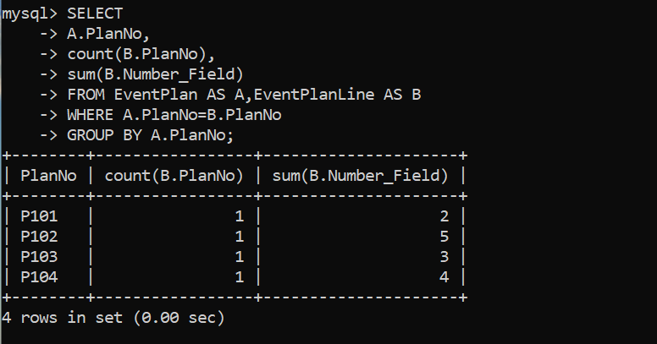

**SELECT**

**-> A.PlanNo,**

**-> count(B.PlanNo),**

**-> sum(B.Number_Field)**

**-> FROM EventPlan AS A,EventPlanLine AS B**

**-> WHERE A.PlanNo=B.PlanNo**

**-> GROUP BY A.PlanNo;**